# 

# Lab 9 Report – AKS Cluster Deployment and Management

* Name : Xihai Ren
* Course: CST8921 010
* Professor : Ragini Madaan
* Date : 2025/07/07

## Objective

The objective of this lab was to deploy and manage a sample web application on Azure Kubernetes Service (AKS). This included creating a Kubernetes cluster, deploying an app, enabling autoscaling, monitoring the cluster, performing a rolling update, and cleaning up resources.

## Steps and Observations

### 1. Create an AKS Cluster

Commands used:

az group create --name aks-lab-rg --location eastus  
az aks create \  
 --resource-group aks-lab-rg \  
 --name aks-lab-cluster \  
 --node-count 2 \  
 --enable-addons monitoring \  
 --generate-ssh-keys

* Successfully created the resource group and AKS cluster with monitoring enabled.

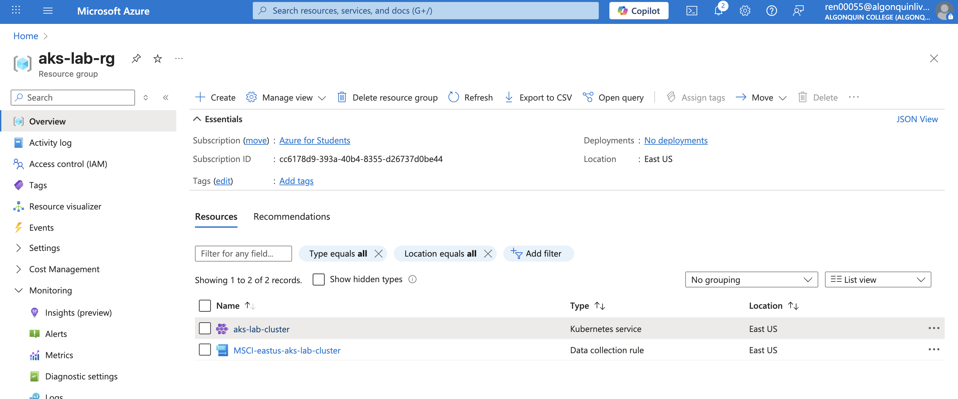

AKS cluster

### 2. Connect to the Cluster

Commands used:

az aks get-credentials --resource-group aks-lab-rg --name aks-lab-cluster  
kubectl get nodes

* Verified access to the cluster and confirmed two nodes were ready. 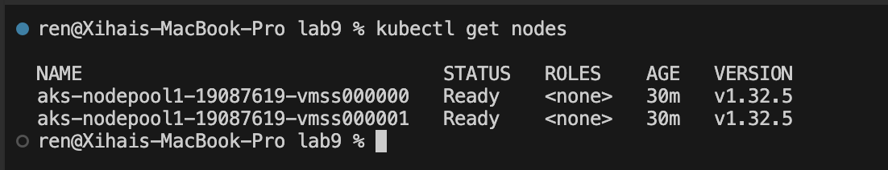

### 3. Deploy a Sample App

Created the following deployment.yaml:

apiVersion: apps/v1  
kind: Deployment  
metadata:  
 name: webapp  
spec:  
 replicas: 2  
 selector:  
 matchLabels:  
 app: webapp  
 template:  
 metadata:  
 labels:  
 app: webapp  
 spec:  
 containers:  
 - name: webapp  
 image: mcr.microsoft.com/aks/periscope:0.0.12  
 ports:  
 - containerPort: 80

Deployment commands:

kubectl apply -f deployment.yaml  
kubectl expose deployment webapp --type=LoadBalancer --port=80  
kubectl get service webapp

* App was successfully deployed and exposed with a public IP.

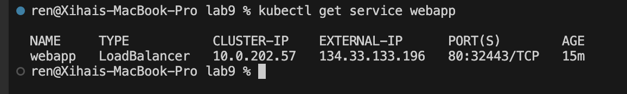

web app service

### 4. Enable Horizontal Pod Autoscaler

Commands used:

kubectl autoscale deployment webapp --cpu-percent=50 --min=2 --max=5  
kubectl get hpa

* Autoscaler created and targeting CPU at 50%. get hpa

### 5. Monitor the Cluster

* Enabled Container Insights through Azure Portal.
* Observed metrics and logs in real time using Azure Monitor.

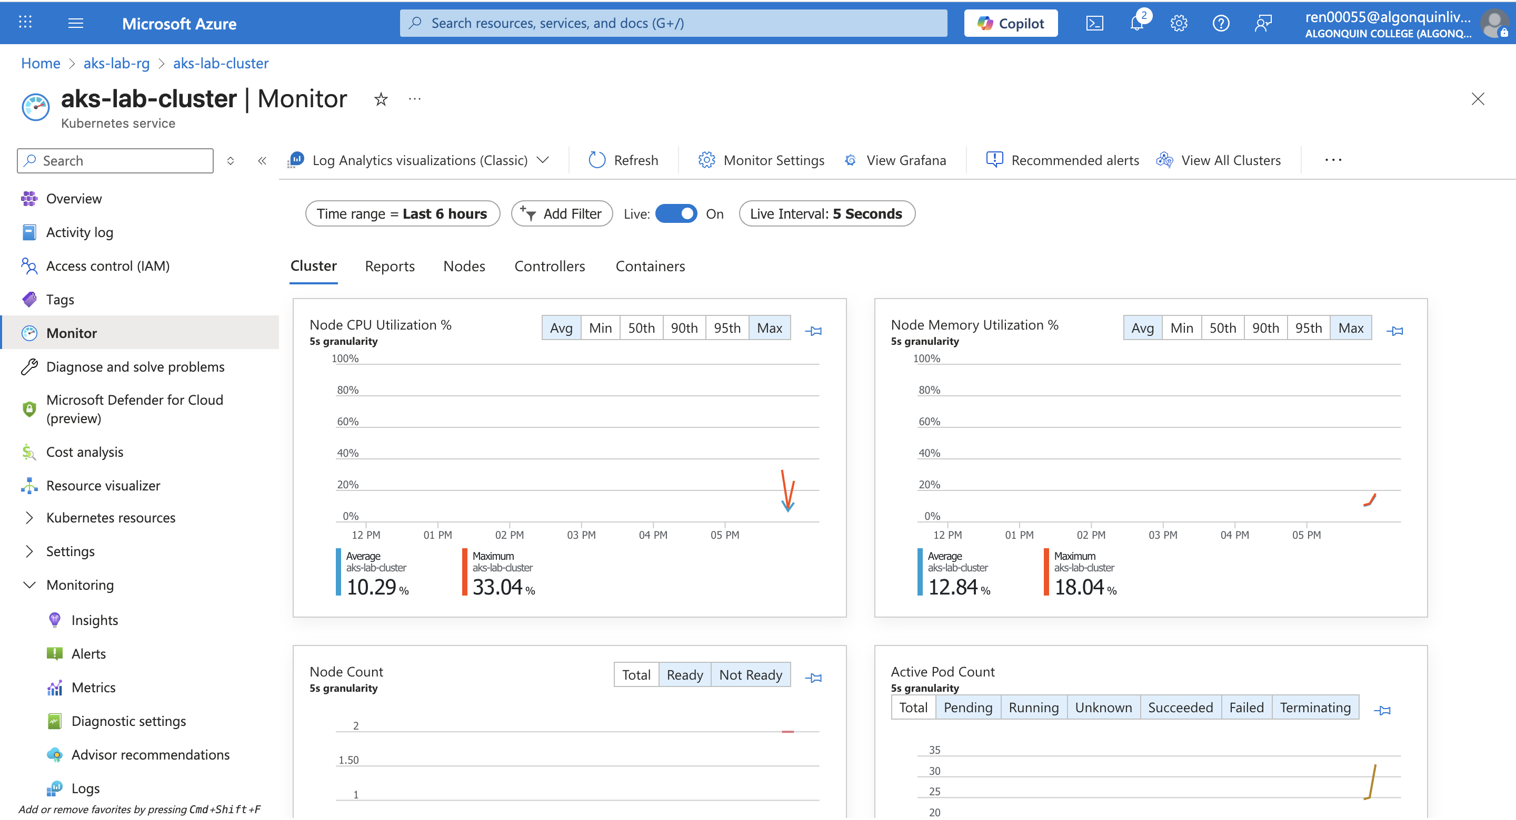

Monitor 1

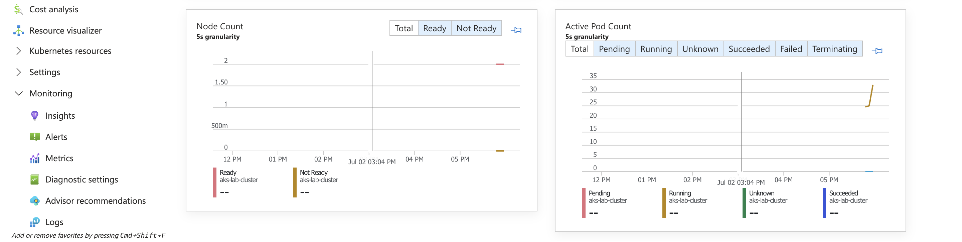

Monitor 2

### 6. Perform a Rolling Update

Command used:

kubectl set image deployment/webapp webapp=mcr.microsoft.com/aks/periscope:0.0.13  
kubectl rollout status deployment/webapp

* Web app image updated with no downtime using rolling update strategy.



update inamge

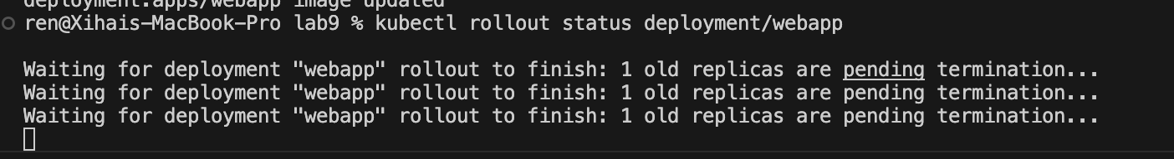

roll out

### 7. Clean Up Resources

Command used:

az group delete --name aks-lab-rg --yes --no-wait

* Deleted the resource group to avoid incurring further costs.



delete resource

## Conclusion

This lab provided hands-on experience with deploying and managing applications on AKS. Key takeaways included provisioning clusters, deploying workloads, configuring autoscaling, monitoring performance, and using rolling updates—all critical skills for real-world cloud-native application management.